Supplementary Figures

Multi-omics refinement of shared genetic architecture and regulatory mechanisms of circulating fatty acids

Abbreviations: DHA%, Percentage of docosahexaenoic acid to total fatty acids; GWAS, Genome-wide association studies; LA%, Percentage of linoleic acid to total fatty acids; MTAG, Multi-trait analysis of GWAS; MUFA, Monounsaturated fatty acids; MUFA%, Percentage of monounsaturated fatty acids to total fatty acids; Omega-3:Omega-6, Omega-3 polyunsaturated fatty acids to omega-6 polyunsaturated fatty acids ratio; Omega-3%, Percentage of omega-3 polyunsaturated fatty acids to total fatty acids; Omega-6%, Percentage of omega-6 polyunsaturated fatty acids to total fatty acids; PUFA, Polyunsaturated fatty acids; PUFA:MUFA, Polyunsaturated fatty acids to monounsaturated fatty acids ratio; PUFA:SFA, Polyunsaturated fatty acids to saturated fatty acids ratio; PUFA%, Percentage of polyunsaturated fatty acids to total fatty acids; SFA, Saturated fatty acids; SFA%, Percentage of saturated fatty acids to total fatty acids; TFA, Total fatty acids.

Table of Contents
Supplementary Figure 1. MTAG discovered additional loci for 14 fatty acid traits 3
Supplementary Figure 2. Gene-set enrichment analyses of candidate genes prioritized across colocalized regions 4
Supplementary Figure 3. Heritability partitioning of circulating fatty acids across MAF and LD 5
Supplementary Figure 4. Cell-type and tissue-specific heritability enrichment using gene expression data 6
Supplementary Figure 5. Cell-type and tissue-specific heritability enrichment using chromatin accessibility data 7
Supplementary Figure 6. Single-cell RNA-sequencing quality control and cell clustering 8
Supplementary Figure 7. Quality control evaluation of single-cell CRISPRi screening data using SCEPTRE 9
Supplementary Figure 8. Gene-set enrichment analyses of cis-target genes from single-cell CRISPRi screen 10
Supplementary Figure 9. Protein-protein interaction network of cis-target genes detected by single-cell CRISPRi screening 11
Supplementary Figure 10. Targeted CRISPRi validation of 16 CRE-gene pairs 12
Supplementary Figure 11: Quantile-quantile plot of association p-values from single-cell CRISPRi calibration 13
Supplementary Figure 12. Genomic distance distribution between CREs targeting the same genes 14

Supplementary Figure 1
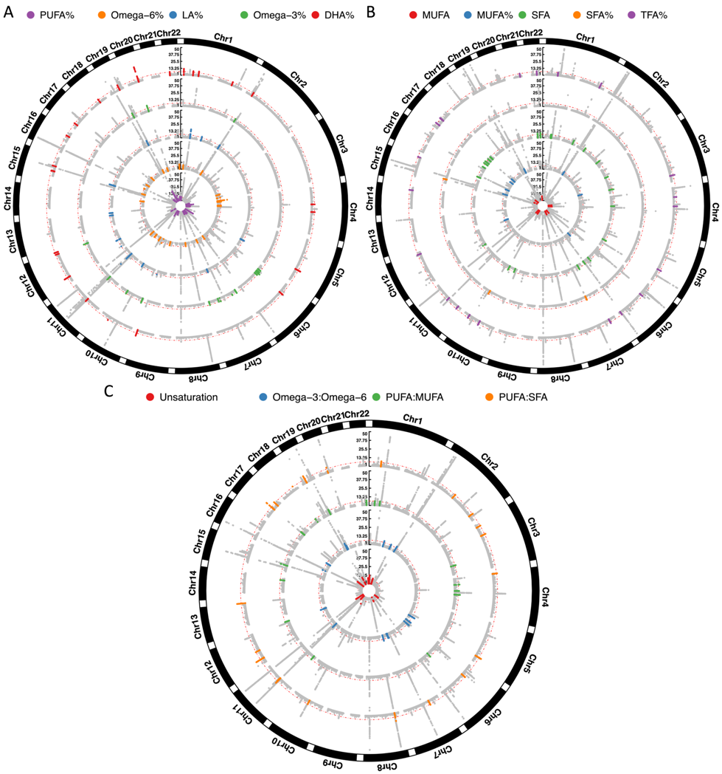

Supplementary Figure 1. MTAG discovered additional loci for 14 fatty acid traits
Circular Manhattan plot showing genomic loci across A) relative percentages of PUFA-related traits, B) SFA-, MUFA- and TFA-related traits, and C) ratios between PUFA-related traits. Circles represent individual traits. The red dashed line denotes the genome-wide significance threshold (P < 5×10⁻⁸). Colored dots highlight variants within novel loci identified by MTAG compared to corresponding single-trait GWAS, while grey dots indicate non-significant variants or loci previously detected in single-trait GWAS. Association p-values < 1×10⁻⁵⁰ are changed to 1×10⁻⁵⁰ for visual clarity.
Supplementary Figure 2
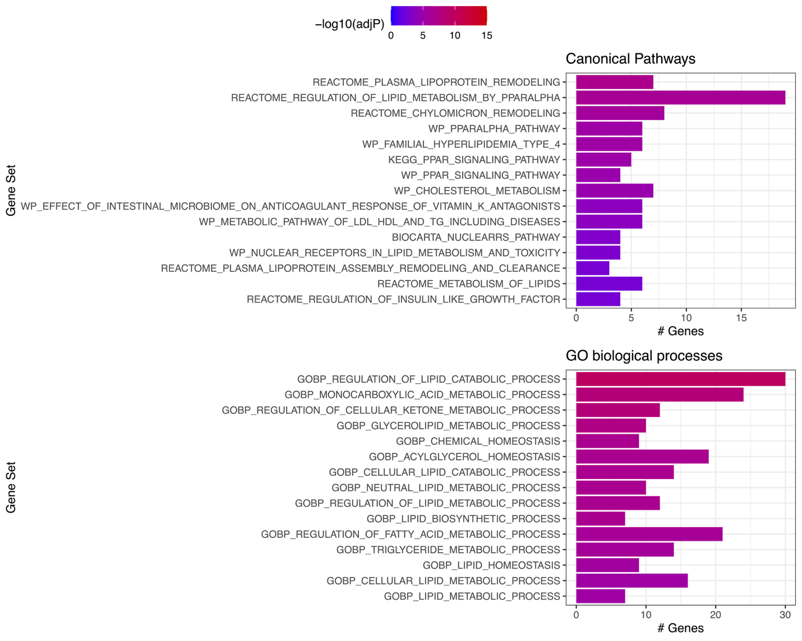

Supplementary Figure 2. Gene-set enrichment analyses of candidate genes prioritized across colocalized regions
Enrichment results for candidate genes identified across 123 colocalized regions, evaluated against canonical pathways and Gene Ontology (GO) biological processes. Candidate genes were annotated using the VEP for candidate regional variants. Bars are colored by FDR-adjusted significance (-log₁₀ adjP).

Supplementary Figure 3
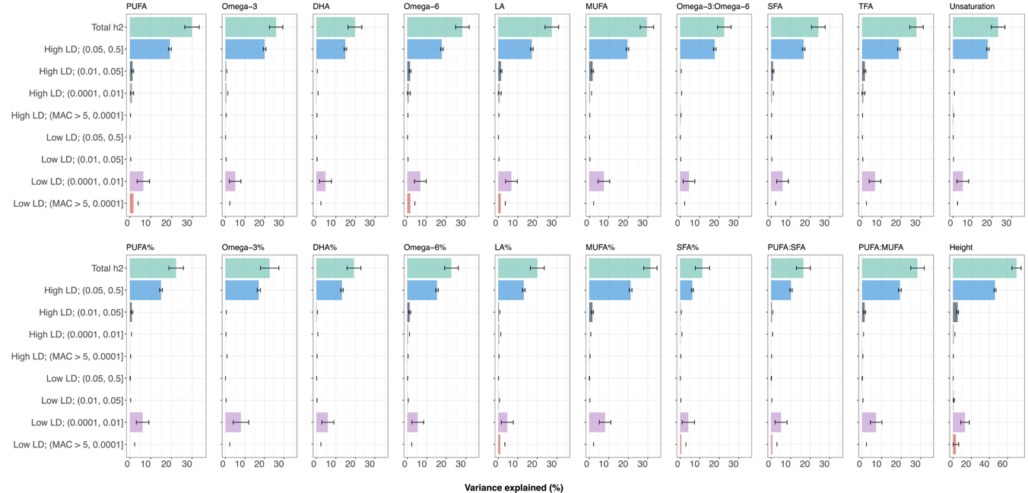

Supplementary Figure 3. Heritability partitioning of circulating fatty acids across MAF and LD
Stratified heritability estimates for circulating fatty acid traits estimated across eight bins, defined by four MAF categories (> 5%, 1-5%, 0.01-1%, and < 0.01%) and two LD score strata (> or ≤ median LD score). Standing height is included as a positive control. Bar colors distinguish the eight MAF-LD bins, and error bars represent standard errors. Abbreviations: MAF, minor allele frequency; LD, linkage disequilibrium.

Supplementary Figure 4
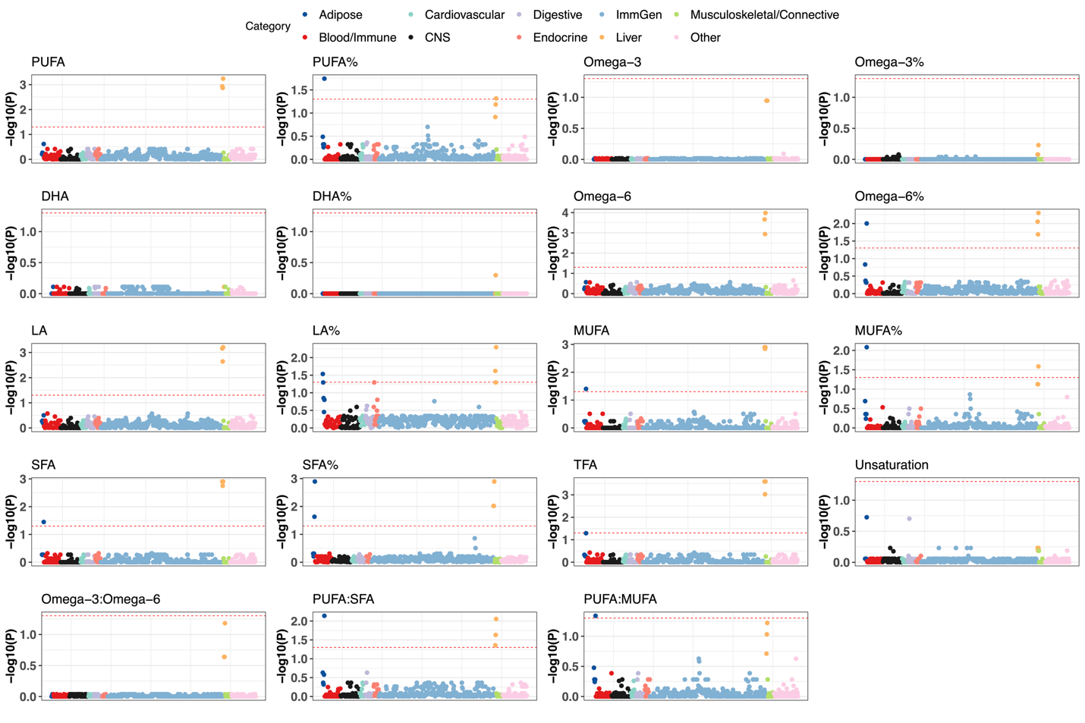

Supplementary Figure 4. Cell-type and tissue-specific heritability enrichment using gene expression data
Partitioned heritability enrichment across cell types and tissues, with colors denoting organ system categories. The red dashed line denotes the significance threshold of 0.05. Multiple testing was corrected using the Benjamini-Hochberg FDR method independently for each trait.

Supplementary Figure 5
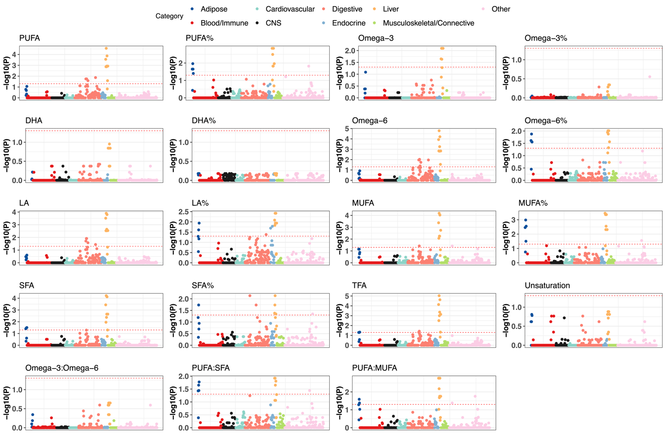

Supplementary Figure 5. Cell-type and tissue-specific heritability enrichment using chromatin accessibility data
Partitioned heritability enrichment across cell types and tissues, with colors denoting organ system categories. The red dashed line denotes the significance threshold of 0.05. Multiple testing was corrected using the Benjamini-Hochberg FDR method independently for each trait.

Supplementary Figure 6
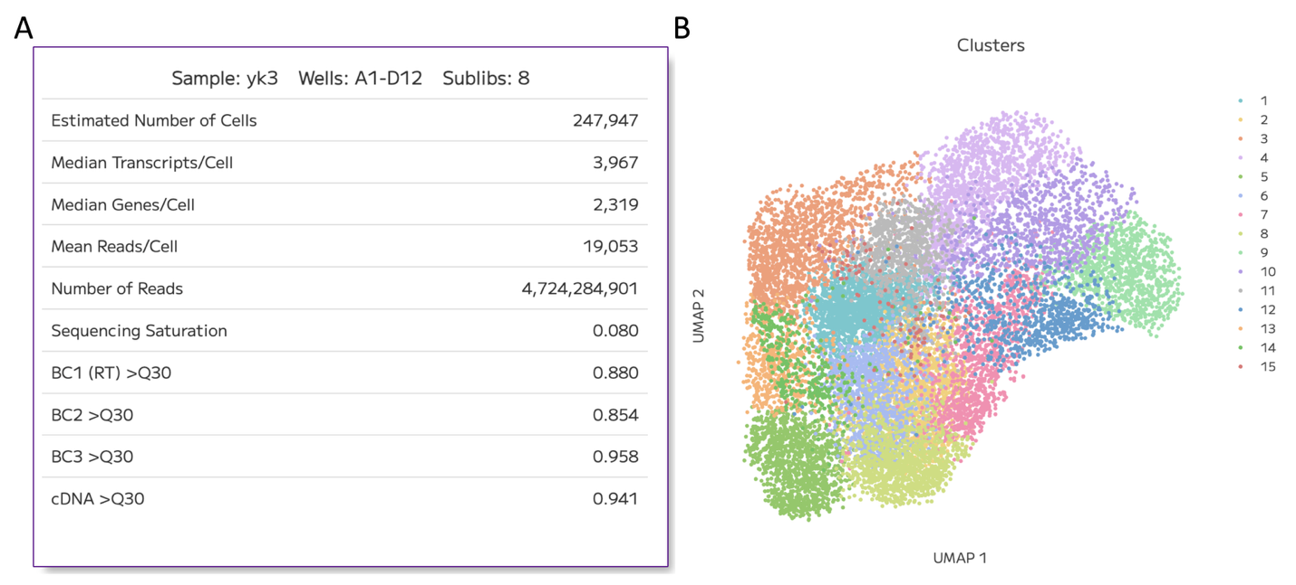

Supplementary Figure 6. Single-cell RNA-sequencing quality control and cell clustering
A) Summary metrics for the Parse Biosciences single-cell RNA-sequencing library, including estimated cells, median transcripts and genes detected per cell, read depth, sequencing saturation and quality score. B) UMAP visualization of HepG2 cells, colored by identified transcriptional clusters. Abbreviations: BC, barcode; UMAP, uniform manifold approximation and projection.

Supplementary Figure 7
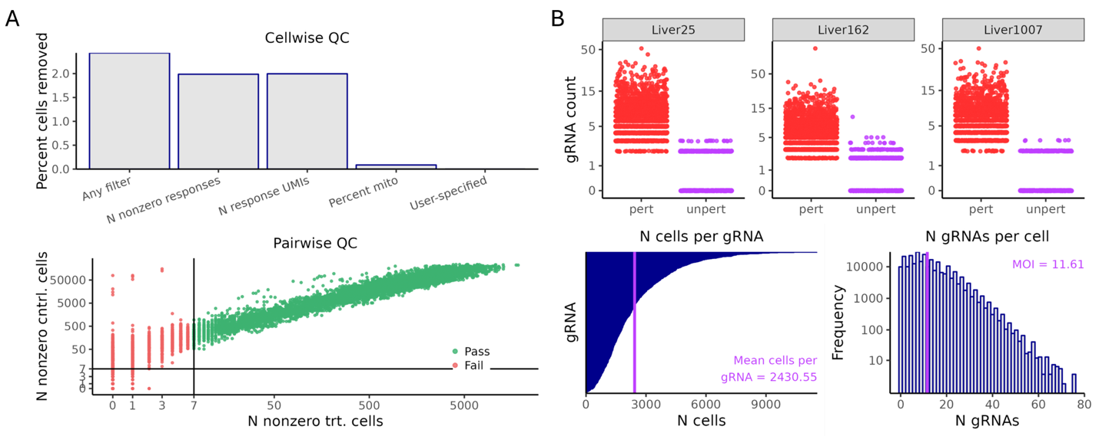

Supplementary Figure 7. Quality control evaluation of single-cell CRISPRi screening data using SCEPTRE
A) Cellwise and pairwise quality control (QC) filtering. Top: percentages of cells excluded, including outliers with nonzero response genes, total response UMIs, and high mitochondrial read percentages. Bottom: pairwise QC assessing candidate gRNA-gene pairs based on the number of nonzero expressing cells in treatment (trt) versus control (cntrl) groups. Green and red dots denote pairs that pass or fail the minimum threshold of seven cells (solid black lines), respectively. B) gRNA assignment, coverage, and multiplicity of infection (MOI) across screening. Top: distribution of gRNA counts across randomly selected targets distinguishing perturbed (pert) from unperturbed (unpert) cells. Bottom left: cumulative coverage of sequenced cells per gRNA, with the vertical line indicating the mean coverage. Bottom right: frequency distribution of detected gRNAs per cell. The vertical line indicates the mean MOI. Abbreviations: QC, quality control; UMI, unique molecular identifier.

Supplementary Figure 8
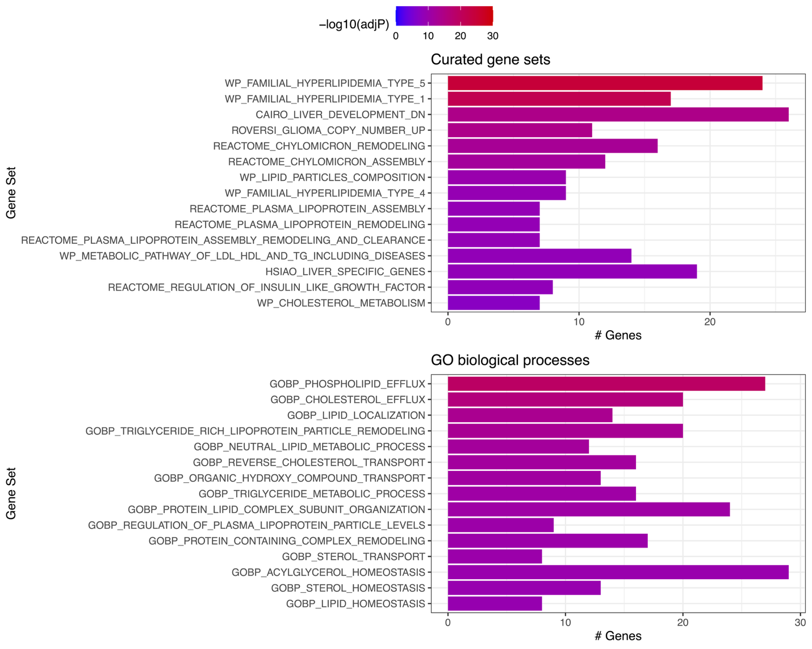

Supplementary Figure 8. Gene-set enrichment analyses of cis-target genes from single-cell CRISPRi screen
Enrichment results for cis-target genes detected by single-cell CRISPRi screening, evaluated against curated gene sets and Gene Ontology (GO) biological processes. Bars are colored by FDR-adjusted significance (-log₁₀ adjP).

Supplementary Figure 9
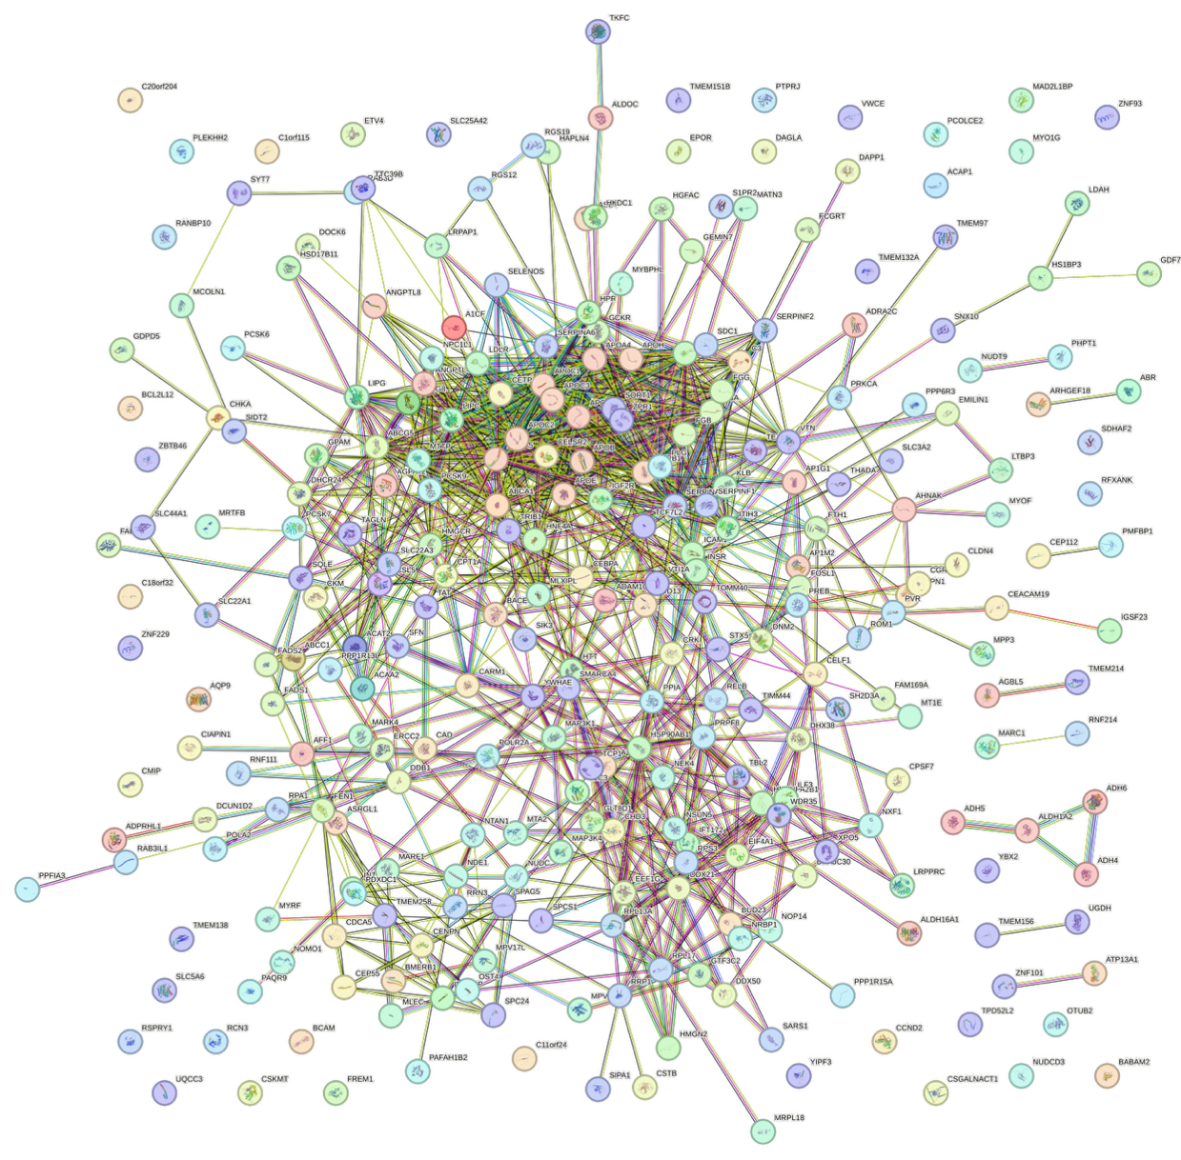

Supplementary Figure 9. Protein-protein interaction network of cis-target genes detected by single-cell CRISPRi screening
The interaction network was generated using the STRING database based on cis-target genes identified from pooled single-cell CRISPRi screening. Nodes represent individual proteins, with colored nodes indicating query proteins and first-shell interactors and white nodes indicating the second shell of interactors. Edges denote functional and physical protein-protein associations, colored by evidence source.
Supplementary Figure 10
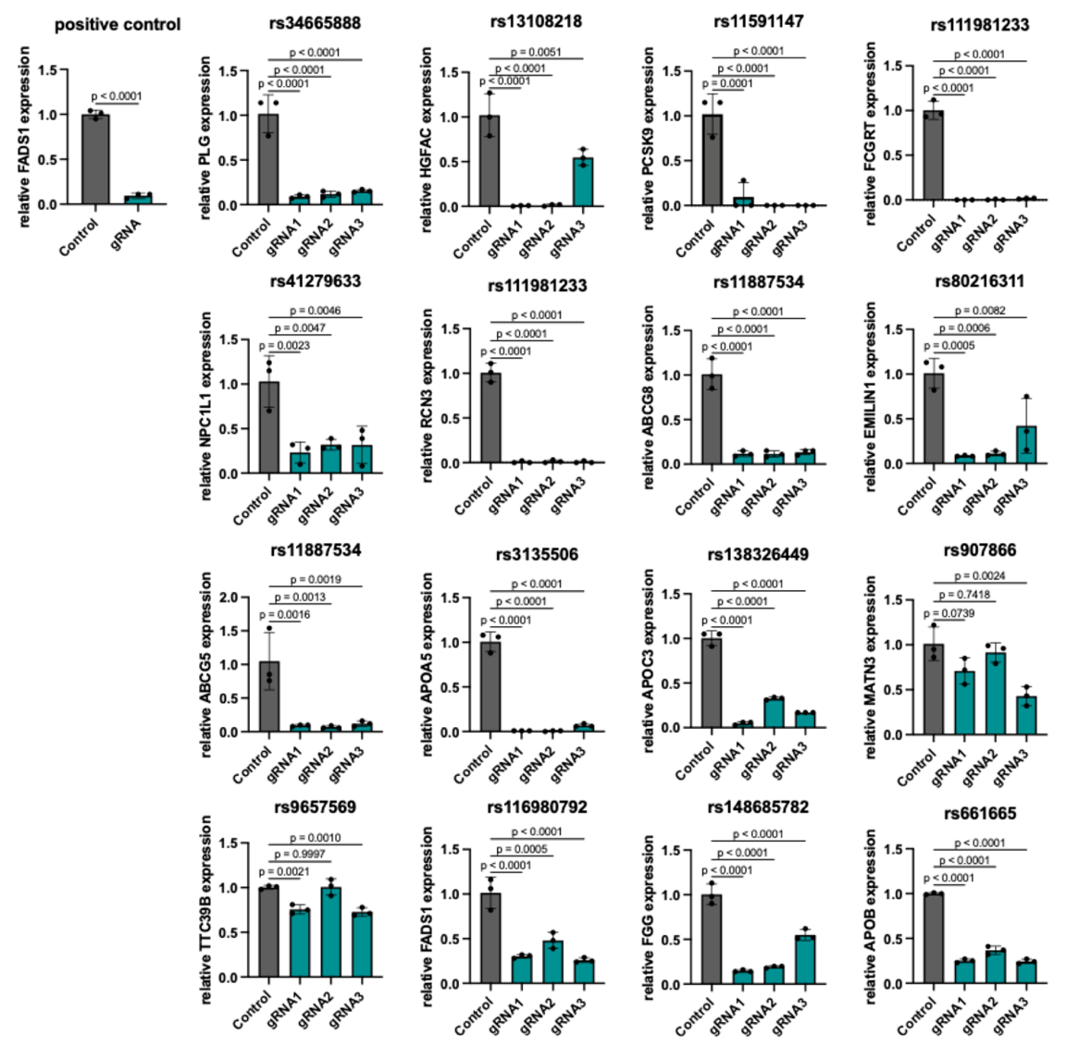

Supplementary Figure 10. Targeted CRISPRi validation of 16 CRE-gene pairs
Validation of candidate functional cis-regulatory elements (CREs) and their detected target genes using arrayed CRISPRi in HepG2 cells. Each CRE is represented by a fine-mapped variant. Panels display the relative mRNA expression levels of target genes following targeted perturbation using three gRNAs (gRNA1-gRNA3) compared with non-targeting negative controls. A positive control targeting the promoter region of FADS1 is shown in the top left. Bar heights represent the mean +- standard error of the mean across three biological replicates, with individual data points displayed as black dots. P-values comparing each gRNA to the negative control are indicated.
Supplementary Figure 11
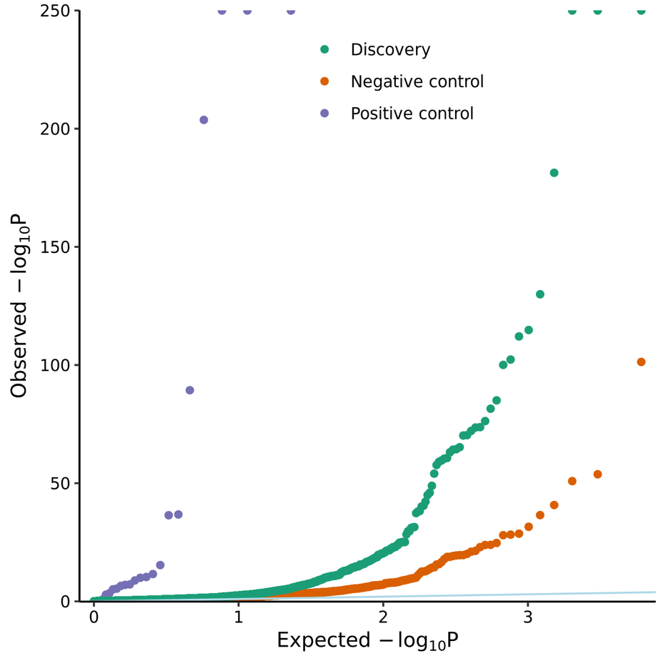

Supplementary Figure 11: Quantile-quantile plot of association p-values from single-cell CRISPRi calibration
Quantile-quantile distribution comparing observed versus expected -log₁₀ P across candidate CRE-gene pairs evaluated by SCEPTRE. Points are grouped into discovery pairs (green), negative control pairs (non-targeting gRNAs; orange), and positive control pairs (targeting transcriptional start sites of 22 genes; purple). The solid light blue diagonal line denotes the null expectation (y=x).

Supplementary Figure 12
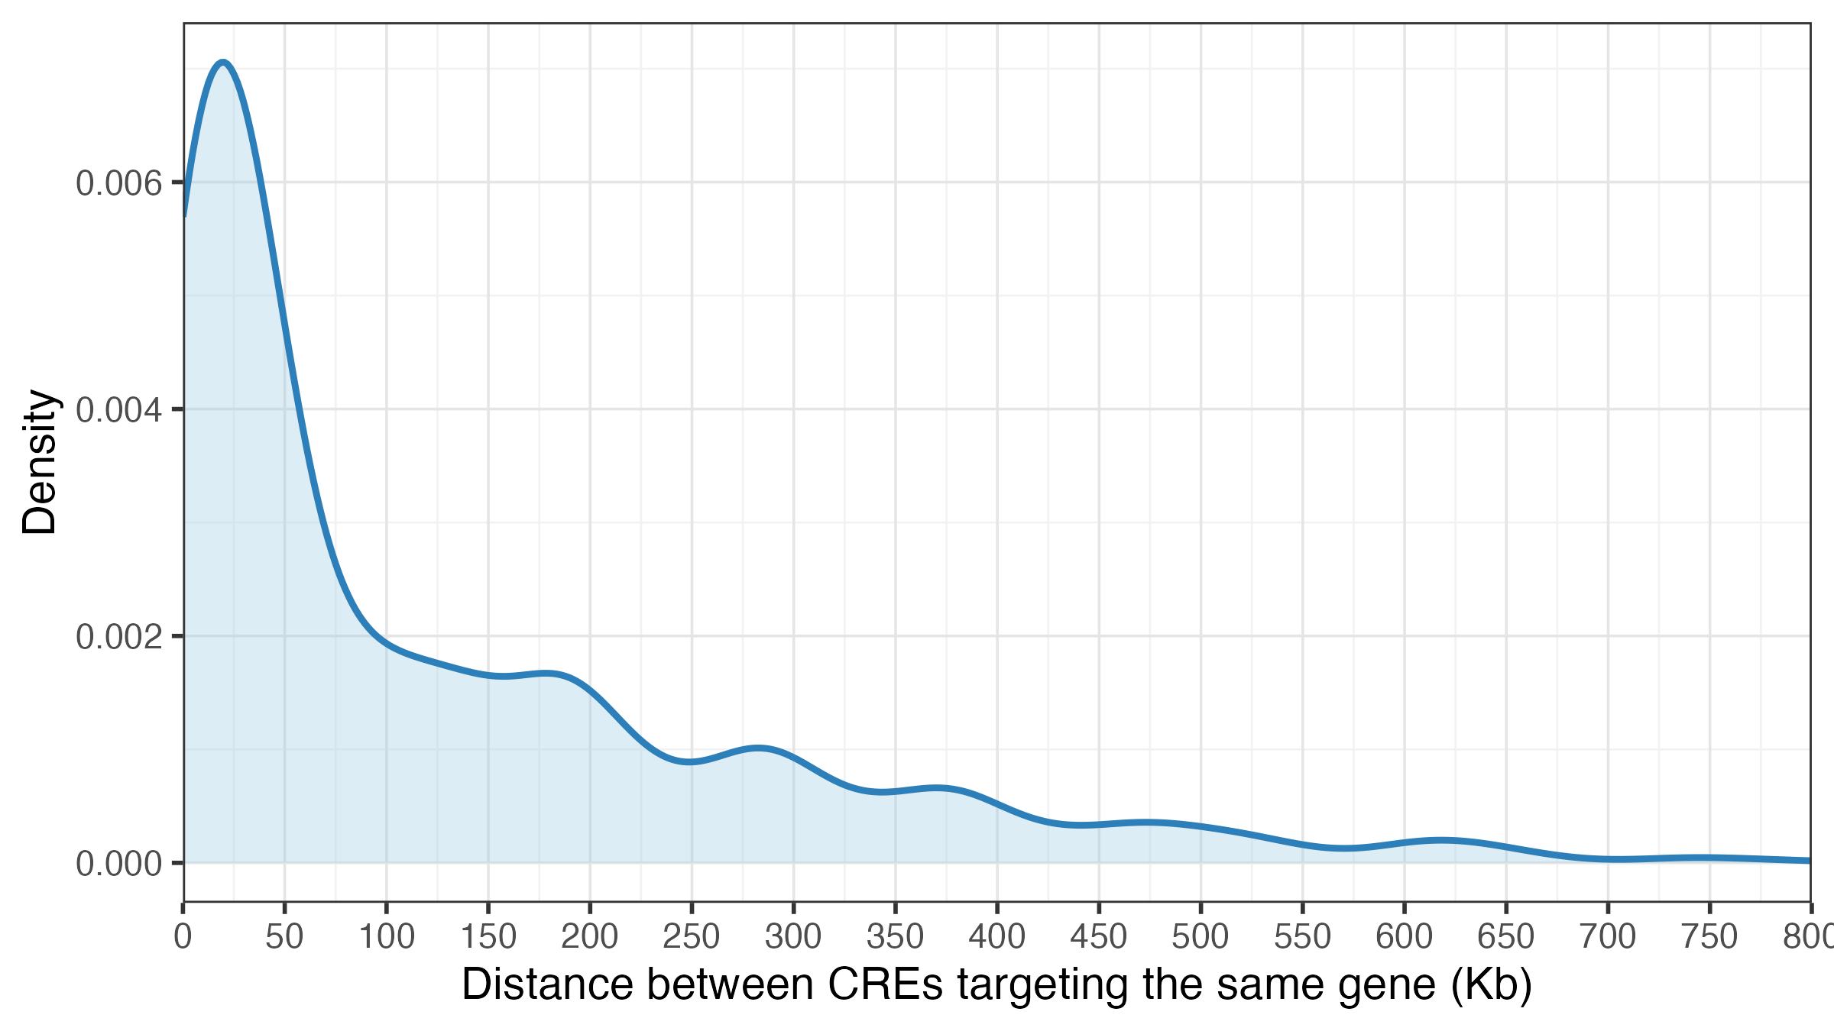

Supplementary Figure 12. Genomic distance distribution between CREs targeting the same genes
Density distribution showing the genomic distances in Kb between pairs of CREs identified as targeting the same gene from single-cell CRISPRi screening. Distances were calculated using the genomic coordinates of fine-mapped variants in each CRE.

